==================================================

Running Genetic Algorithm...

==================================================

==================================================

=== GENETIC ALGORITHM OPTIMIZATION ===

==================================================

[Initialization]

- Population size: 30

- Generations: 20

- Crossover rate: 80%

- Mutation rate: 20%

- Search space: 14 features

- Target: Minimize MSE using CatBoost

==================================================

=== OPTIMIZATION RESULTS ===

==================================================

▶ Best MSE achieved: 0.501522

▶ Time elapsed: 461.69 seconds

▶ Features selected: 14/14 (0.0% reduction)

▶ Selected features:

1. 0

2. 1

3. 2

4. 3

5. 4

6. 5

7. 6

8. 7

9. 8

10. 9

11. 10

12. 11

13. 12

14. 13

▶ Convergence progress:

- Initial MSE: 0.5026

- Final MSE: 0.5015

- Improvement: 0.2%

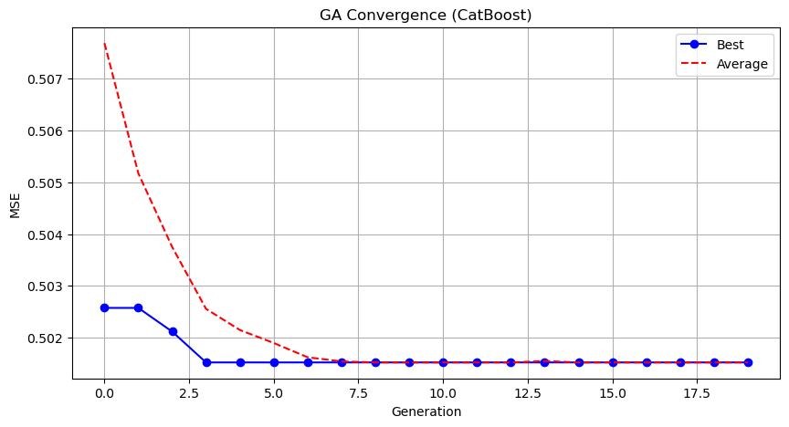

Genetic Algorithm completed successfully with MSE: 0.5015

==================================================

Running Particle Swarm Optimization...

==================================================

==================================================

=== PARTICLE SWARM OPTIMIZATION ===

==================================================

[Initialization]

- Swarm size: 30 particles

- Iterations: 20

- Cognitive weight: 0.5

- Social weight: 0.5

- Inertia weight: 0.5

- Search space: 14 features

- Target: Minimize MSE using CatBoost

==================================================

=== OPTIMIZATION RESULTS ===

==================================================

▶ Best MSE achieved: 0.501522

▶ Time elapsed: 484.87 seconds

▶ Features selected: 14/14 (0.0% reduction)

▶ Selected features (with weights):

1. 0 (weight: 0.545)

2. 1 (weight: 0.888)

3. 2 (weight: 0.518)

4. 3 (weight: 0.811)

5. 4 (weight: 0.737)

6. 5 (weight: 0.781)

7. 6 (weight: 0.781)

8. 7 (weight: 0.957)

9. 8 (weight: 0.633)

10. 9 (weight: 0.769)

11. 10 (weight: 0.999)

12. 11 (weight: 1.000)

13. 12 (weight: 0.898)

14. 13 (weight: 0.546)

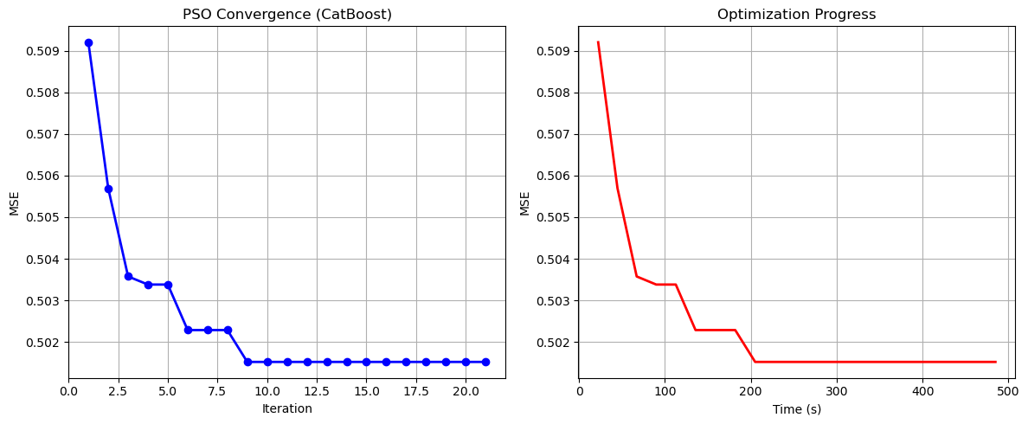

Particle Swarm Optimization completed successfully with MSE: 0.5015

==================================================

Running Whale Optimization...

==================================================

==================================================

=== WHALE OPTIMIZATION ALGORITHM ===

==================================================

[Initialization]

- Population: 30 whales

- Max iterations: 20

- Spiral coefficient (b): 1.0

- Search space: 14 features

- Target: Minimize MSE using CatBoost

[Optimization Progress]

Iter 20/20 | Best MSE: 0.501522

==================================================

=== OPTIMIZATION RESULTS ===

==================================================

▶ Best MSE achieved: 0.501522

▶ Time elapsed: 470.20 seconds

▶ Features selected: 14/14 (0.0% reduction)

▶ Selected features:

1. 0

2. 1

3. 2

4. 3

5. 4

6. 5

7. 6

8. 7

9. 8

10. 9

11. 10

12. 11

13. 12

14. 13

▶ Convergence progress:

- Initial MSE: 0.5150

- Final MSE: 0.5015

- Improvement: 2.6%

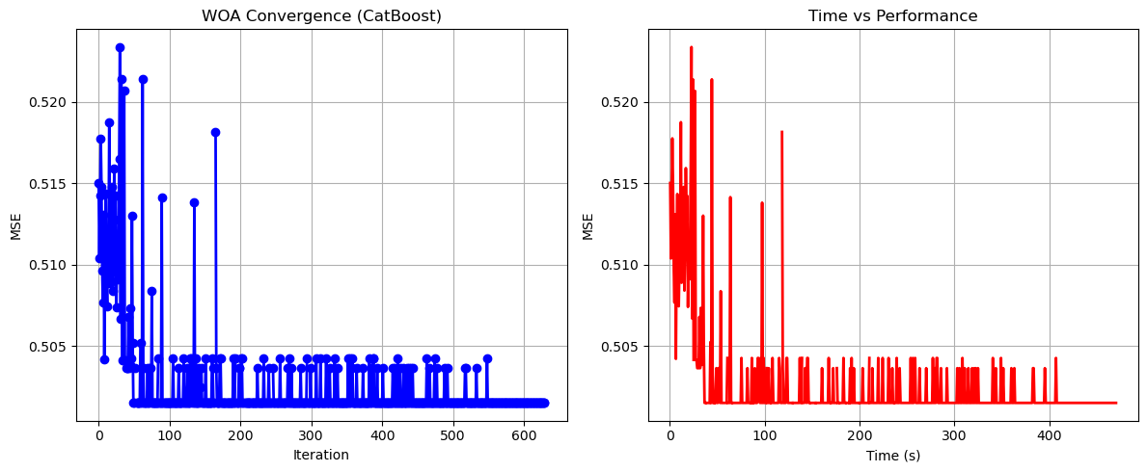

Whale Optimization completed successfully with MSE: 0.5015

==================================================

Running Squid Game Optimizer...

==================================================

==================================================

=== SQUID GAME OPTIMIZER (SGO) ===

==================================================

[Initialization]

- Players: 30 (15 offensive, 15 defensive)

- Max games: 20

- Search space: 14 features

- Target: Minimize MSE using CatBoost

==================================================

=== OPTIMIZATION RESULTS ===

==================================================

▶ Best MSE achieved: 0.502064

▶ Time elapsed: 476.96 seconds

▶ Features selected: 12/14 (14.3% reduction)

▶ Selected features:

1. 0

2. 1

3. 2

4. 3

5. 4

6. 5

7. 6

8. 8

9. 9

10. 11

11. 12

12. 13

▶ Convergence progress:

- Initial MSE: 0.5043

- Final MSE: 0.5021

- Improvement: 0.4%

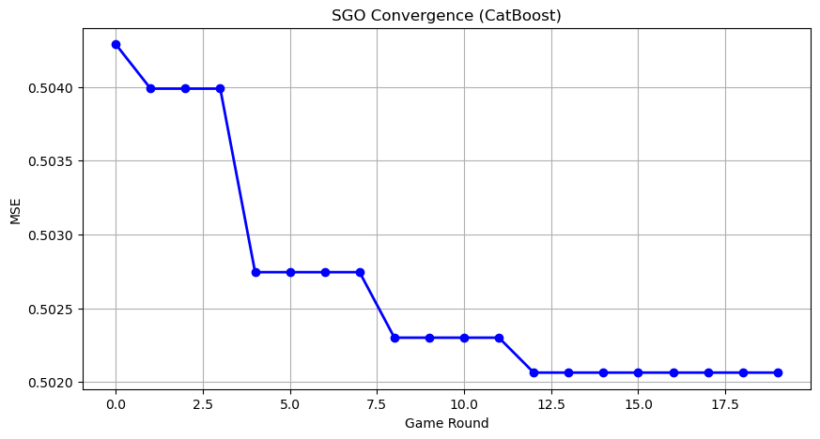

Squid Game Optimizer completed successfully with MSE: 0.5021

==================================================

Running PSH-Hyptrite...

==================================================

==================================================

=== PSH-HYPTRITE OPTIMIZATION ===

==================================================

[Initialization]

- Search points: 30

- Max iterations: 20

- Initial radius: 0.5 (adaptive)

- Hypersphere samples: 3 per point

- Search space: 14 features

- Target: Minimize MSE using CatBoost

[Optimization Progress]

Iter 20/20 | Best MSE: 0.501522 | Radius: 0.0250

==================================================

=== OPTIMIZATION RESULTS ===

==================================================

▶ Best MSE achieved: 0.501522

▶ Time elapsed: 1415.18 seconds

▶ Features selected: 14/14 (0.0% reduction)

▶ Selected features (with weights):

1. 0 (weight: 0.924)

2. 1 (weight: 0.540)

3. 2 (weight: 0.792)

4. 3 (weight: 0.676)

5. 4 (weight: 0.577)

6. 5 (weight: 0.738)

7. 6 (weight: 0.768)

8. 7 (weight: 0.787)

9. 8 (weight: 0.517)

10. 9 (weight: 0.832)

11. 10 (weight: 0.768)

12. 11 (weight: 0.891)

13. 12 (weight: 0.771)

14. 13 (weight: 0.606)

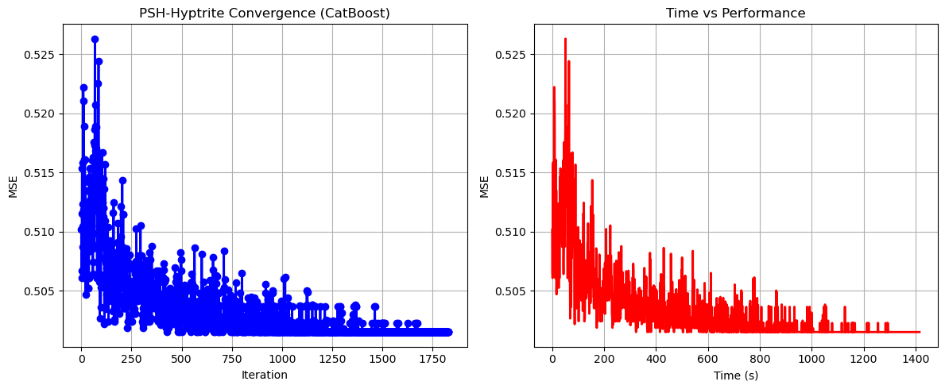

PSH-Hyptrite completed successfully with MSE: 0.5015

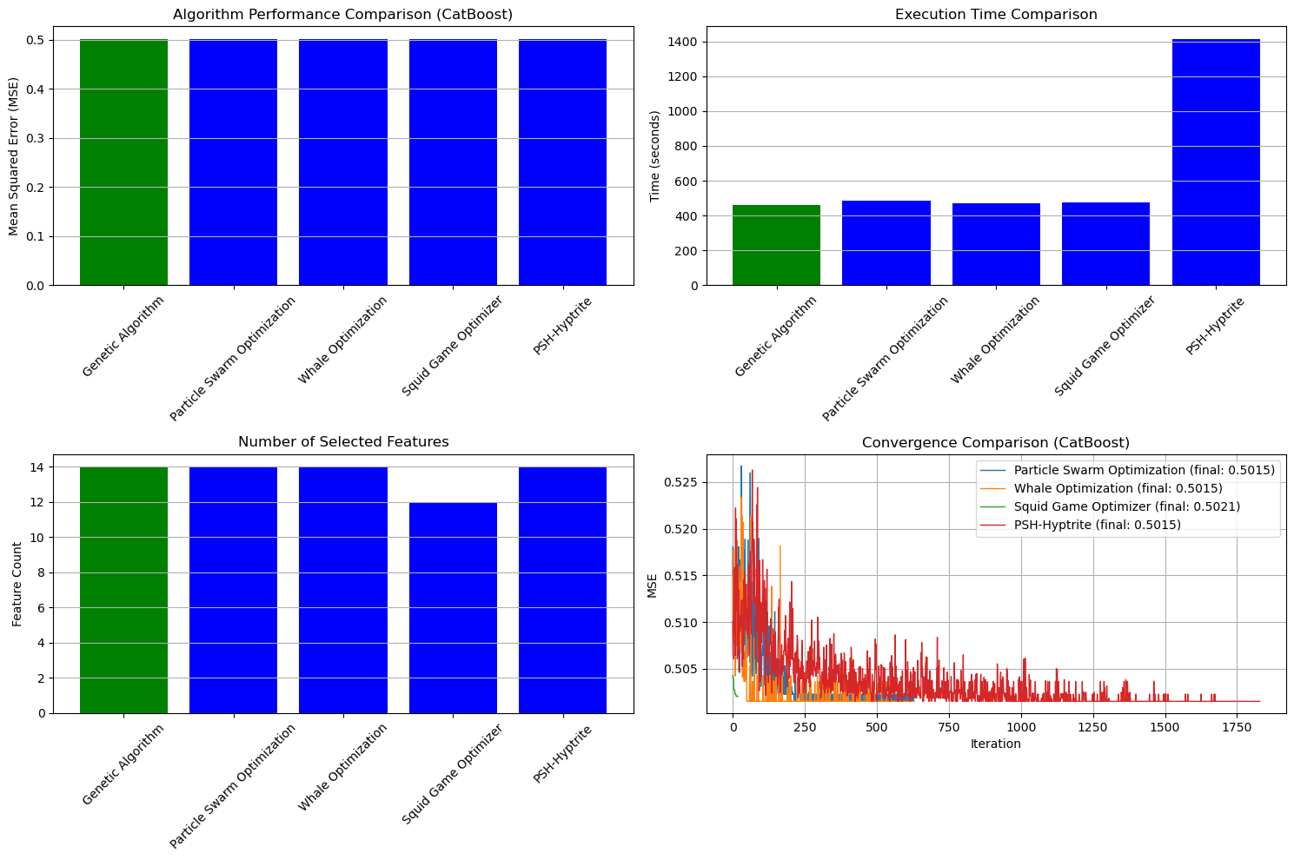

==================================================

FINAL RESULTS SUMMARY (Using CatBoost)

==================================================

🏆 Best Algorithm: Genetic Algorithm

📉 Best MSE Achieved: 0.501522

⏱️ Execution Time: 461.69 seconds

🔢 Features Selected: 14

Selected Features:

1. 0

2. 1

3. 2

4. 3

5. 4

6. 5

7. 6

8. 7

9. 8

10. 9

11. 10

12. 11

13. 12

14. 13